
APPLICATION
DEVELOPMENT THEORY 4
Data Design for the Tourism System
Term 2 Assignment 3

Group Members:

No. | Surname and Name | Student Number
1 | Kabai Moipone | 2 | 1 | 5 | 2 | 0 | 3 | 5 | 6 | 9
2 | Msomi Sebe | 2 | 1 | 6 | 0 | 2 | 8 | 6 | 0 | 4

Due Date: 13 June 2020
- Software Development Approach
A software development approach that would not be suitable for our system is the Waterfall Model. The reason to that is because the phases are linked to each other such that each phase must be completed before the next phase can begin, thus time consuming. During design, problems with requirements are usually identified and also during the development phase, design problems are found also, and so on. Because the software process is not a simple linear model but involves feedback from one phase to another, document produced in each phase may then have to be modified to reflect the changes made. During the final life cycle phase; that is, Maintenance, the software is put into use then errors in the original software requirements are discovered. Program and design errors emerge and the need for new functionality is identified. The system must therefore evolve to remain useful, thus may highly result in the system not being what the user wants due to not being able to rollback or make changes in a phase we see fit.
Additionally, in order for the Waterfall Model to be perfect and fit customer needs, it has to be planned out for a very long period of time to meet all the requirements. So the planning phase might even take up to a year to make sure that every aspect has been covered so that there won’t be a need to rollback to previous phases. For our system we do not have that amount of time because the tourism space is becoming increasingly popular to an extent that dragging it for a long time will affect the project schedule that is allocated.

Use Case Diagram
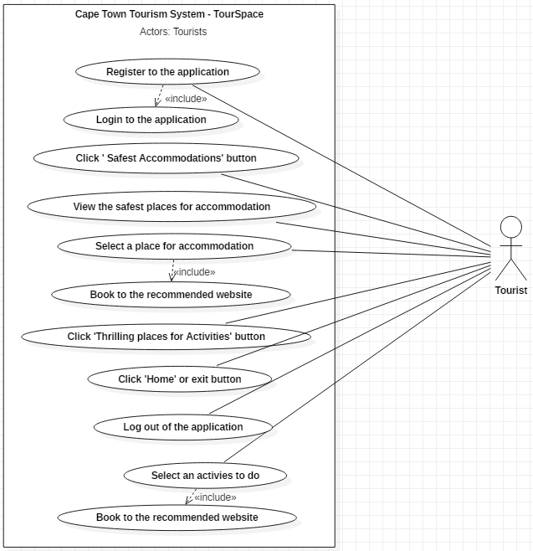

Data Design: Class diagram
